DOMESTIC VIOLENCE SCREENING/DOCUMENTATION FORM

DV Screen
ٱ DV + (Positive)
ٱ DV ? (Suspected)

Date: ____________ Patient ID# ___________
Patient Name __________________________

Provider Name _________________________

Patient Pregnant? ٱ Yes ٱ No

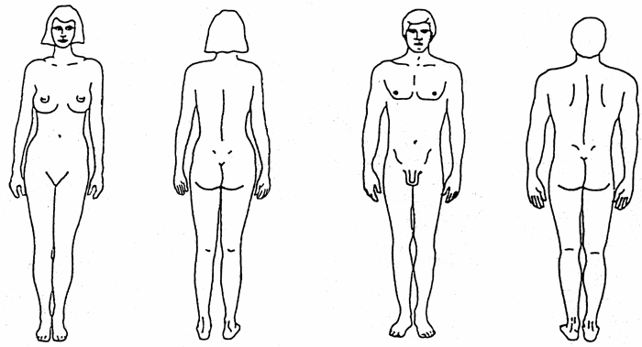

ASSESS PATIENT SAFETY |  |  | REFERRALS
ٱ Yes | ٱ No | Is abuser here now? | ٱ Hotline number given
ٱ Yes | ٱ No | Is patient afraid of their partner? | ٱ Legal referral made
ٱ Yes | ٱ No | Is patient afraid to go home? | ٱ Shelter number given
ٱ Yes | ٱ No | Has physical violence increased in severity? | ٱ In-house referral made  Describe:_______________________
ٱ Yes | ٱ No | Has partner physically abused children? | ٱ Other referral made  Describe: ______________________
ٱ Yes | ٱ No | Have children witnessed violence in the home? | REPORTING
ٱ Yes | ٱ No | Threats of homicide?  By whom: _______________ | ٱ Law enforcement report made  ٱ Child Protective Services report made
ٱ Yes | ٱ No | Threats of suicide?  By whom: _______________ | ٱ Adult Protective Services report made
ٱ Yes | ٱ No | Is there a gun in the home? | PHOTOGRAPHS
ٱ Yes | ٱ No | Alcohol or substance abuse? | ٱYes ٱNo Consent to be photographed?
ٱ Yes | ٱ No | Was safety plan discussed? | ٱYes ٱNo Photographs taken?
Attach photograph and consent form

PROGRESS NOTES Date: ___________________
(Using S.O.A.P. Format) Time: __________________

[Describe frequency and severity of present and past abuse (use direct quotes); describe mechanism, location and extent of injury and/or other symptoms/condition.]

_____________________________________________________________________________
____________________________________________________________________________________________________________________________________________________________________________________________________________________________________________________________________________________________________________________
______________________________________________________________________________________________________________________________________________________________________________________________________________________________________________________________________________________________________________________________________________________________________________________________________________________________________________________________________________
______________________________________________________________________________________________________________________________________________________________________________________________________________________________________________________________________________________________________________________________________________________________________________________________________________________________________________________________________________
______________________________________________________________________________________________________________________________________________________________________________________________________________________________________________________________________________________________________________________________________________________________________________________________________________________________________________________________________________
______________________________________________________________________________________________________________________________________________________________________________________________________________________________________________________________________________________________________________________________________________________________________________________________________________________________________________________________________________
______________________________________________________________________________________________________________________________________________________________________________________________________________________________________________________________________________________________________________________________________________________________________________________________________________________________________________________________________________
______________________________________________________________________________________________________________________________________________________________________________________________________________________________________________________________________________________________________________________________________________________________________________________________________________________________________________________________________________
______________________________________________________________________________________________________________________________________________________________________________________________________________________________________________________________________________________________________________________________________________________________________________________________________________________________________________________________________________

